ГОСУДАРСТВЕННОЕ БЮДЖЕТНОЕ ПРОФЕССИОНАЛЬНОЕ ОБРАЗОВАТЕЛЬНОЕ УЧРЕЖДЕНИЕ САМАРСКОЙ ОБЛАСТИ

«САМАРСКИЙ СОЦИАЛЬНО-ПЕДАГОГИЧЕСКИЙ КОЛЛЕДЖ»

**учебное пособие**

**по организации практических занятий по дисциплине**

**ОГСЭ.04 Иностранный (английский) язык**

для обучающихся по специальностям:

44.02.02 Преподавание в начальных классах,



**г.о. САМАРА, 2022**

*Печатается по решению*

*научно-методического совета*

*государственного бюджетного профессионального*

*образовательного учреждения*

*Самарской области*

*«Самарский социально – педагогический колледж»*

**Учебное пособие** по организации практической работы по дисциплине ОГСЭ.04 «Иностранный (английский) язык»: учебно-методическое пособие для обучающихся по специальности: 44.02.02 Преподавание в начальных классах/ Протасова Е.А., Драгина К.Ю. – Самара, 2022. - 64с. - 50 экз.

**Автор-составители:**

Протасова Е.А., преподаватель ГБПОУ «ССПК»

Драгина К.Ю.преподаватель ГБПОУ «ССПК»

##### © ГБПОУ «ССПК», 2022

© Драгина К.Ю., Протасова Е.А., 2022

**ПОЯСНИТЕЛЬНАЯ ЗАПИСКА**

Данное учебное пособие предназначено для обучающихся по специальности: 44.02.02 Преподавание в начальных классах и содержит учебно-методические материалы для организации практический.

Цель данного пособия: развитие у обучаемых навыков и умений самостоятельно читать оригинальную литературу, связанную с педагогической деятельностью, извлекать из этих текстов необходимую информацию в пределах проработанной тематики, делать сообщения на заданную тему, используя как общеупотребительную лексику, так и специальную педагогическую терминологию.

Пособие позволят студентам усвоить знания и освоить умения, требуемые Программой. В результате освоения учебной дисциплины обучающийся должен **уметь**:

- общаться (устно и письменно) на иностранном языке на профессиональные и повседневные темы;

- переводить (со словарем) иностранные тексты профессиональной направленности;

- самостоятельно совершенствовать устную и письменную речь, пополнять словарный запас.

В результате освоения учебной дисциплины обучающийся должен **знать:**

- лексический (1200-1400 лексических единиц) и грамматический минимум, необходимый для чтения и перевода (со словарем) иностранных текстов профессиональной направленности.

Изучение программного материала должно способствовать формированию у обучающихся следующих общих компетенций (ОК):

**ОК 1.** Понимать сущность и социальную значимость своей будущей профессии, проявлять к ней устойчивый интерес.

**ОК 2.** Организовывать собственную деятельность, определять методы решения профессиональных задач, оценивать их эффективность и качество.

**ОК 4.** Осуществлять поиск, анализ и оценку информации, необходимой для постановки и решения профессиональных задач, профессионального и личностного развития.

**ОК 5.** Использовать информационно-коммуникационные технологии для совершенствования профессиональной деятельности.

**ОК 6.** Работать в коллективе и команде, взаимодействовать с коллегами и социальными партнерами.

**ОК 8.** Самостоятельно определять задачи профессионального и личностного развития, заниматься самообразованием.

Данное пособие строиться на основе использования личностно-ориентированного подхода в преподавании, разноуровневого и проблемного обучения, игровых приемов и ИКТ технологий, проектно-исследовательских технологий. Предлагаемое учебное пособие рассчитано на 38 часов аудиторной работы и включает в себя 4 модуля, содержащих дидактические материалы и задания для практических и самостоятельных занятий:

1. Жизнь в колледже (College Life);

2. На уроке (At the Lesson);

3. Профессия учителя (Teacher’s Profession);

4. Образование (Education);

Каждый модуль состоит из нескольких уроков (Units).

Урок начинается с профессионально ориентированного текста, направленного на актуализацию лексики данного занятия. Каждый урок включает задания на развитие всех видов речевой деятельности: аудирования, говорения, различных видов чтения (ознакомительного, поискового, с полным пониманием прочитанного) и письма. Основным материалом для аудиторной и последующей самостоятельной работы в каждом уроке является базовый текст, сопровождаемый рядом заданий и упражнений, активизирующих различные виды речевой деятельности, при этом, основное внимание уделено переводу.

Упражнения “Answer the questions”, приучают студента вдумчиво читать текст и способствуют развитию навыков устной речи. Упражнения типа “Give English (Russian) equivalents for the following”,способствуют закреплению полезных и употребительных слов и словосочетаний, вырабатывают у студента умение найти нужный эквивалент при переводе с русского языка на английский и наоборот. Упражнения “Grammar Focus” содержит дополнительный материал о правилах употреблениях рассмотренных в данной методической разработке грамматических единиц в английском языке. Во многих урока представлены упражнения-игры, чтобы еще раз отработать изученную лексику, но уже в игровой форме.

В конце урока обучающимся предлагается выполнить проектное задание, рассчитанное на то, чтобы дать студенту возможность более широко использовать накопленный им лексический материал.

Для проведения некоторых аудиторных занятий необходимо использование технических средств обучения: магнитофон, проигрыватель компакт-дисков, телевизор, DVD-проигрыватель, проектор, ноутбук, экран.

Модули построены по принципу избыточности материала, так чтобы у преподавателя была возможность выбора задания и реализации принципа индивидуализации процесса обучения. Оценки за выполнение практических работ выставляются по пятибалльной системе. Оценки за практические работы являются обязательными текущими оценками по учебной дисциплине и выставляются в журнале.

Условные обозначения:

- задание повышенной сложности

 - задание для аудирования



- работа с интернетом

**CONTENTS**

|  |  |
| --- | --- |
| **Module 1. COLLEGE LIFE** ……………………………………….  Unit 1. Vocabulary Work…………………………………………….  Unit 2. Studying at College/University ……………………………....  **Module 2. AT THE LESSON** ………………………………………  Unit 1. First Lesson …………………………………………………..  Unit 2.Unusual Lessons ………………………………………………  **Module 3. TEACHER’S PROFESSION** …………………………..  Unit 1.Career Plans …………………………………………….……..  Unit 2. A Good Teacher ………………………………………………  **Module 4. EDUCATION** ……………………………………………  Unit. 1 The World of Learning ………………………………….……  Unit 2. Around the World …………………………………….………  **Appendix**…………………………………………………….….……. | **6**  **6**  **12**  **19**  **19**  **25**  **30**  **30**  **35**  **40**  **40**  **47**  **53** |

**MODULE 1. COLLEGE LIFE**

**Unit 1. VOCABULARY WORK**

1. **Study this contrastive entry of the word ‘student’.**

|  |  |
| --- | --- |
| **STUDENT**  **‘schoolchildren’**  **‘pupils’**  **‘children’** | In British English, a **student** is someone who is studying or training at a university or college.  *...medical students.*  *...the students of Edinburgh University.*  In American English, anyone who studies at a school, college, or university can be referred to as a **student**.  *...high school students.*  In British English, children attending schools are referred to generally as **schoolchildren**, **schoolboys**, or **schoolgirls**.  *Each year the sanctuary is visited by thousands of schoolchildren.*  *...when I was still a schoolboy.*  *...the number of schoolgirls attracted to engineering.*  In Britain, the children attending a particular school are officially referred to as its **pupils**.  *...a school with more than 1300 pupils.*  However, in conversation you talk about the **children** at a school, not its ‘pupils’.  *We have forty-three children in Fairacre School.* |

1. **Translate the words and phrases:**

go to university / college

………………………………………

get a place at (Oxford)

………………………………………

read (= study) (Pedagogy)

………………………………………

go to lectures / seminars / tutorials

………………………………………

get a degree

……………………………………….

do a course in (Psychology)

……………………………………….

do (Music)

……………………………………….

undergraduate

……………………………………….

graduate

……………………………………….

postgraduate

……………………………………….

do research

……………………………………….

1. **Read the sentences and translate them in written form.**

A math **teacher teaches** math. His/Her **students study** math. After school, students **do** their **homework**.

In elementary school, children **learn to read and write**.

A university teacher/professor **gives a lecture**, and the students **take notes**.

Students **take courses** in colleges and schools. At the end of a course, you often have to **take an exam**. You hope to **pass** your **exams**. You don’t want to **fail** your **exams**.

If you complete your courses and pass the exams at a university, you **get a degree**.

1. **Grammar focus. Choose verbs from exercise 3 to fill in the blanks below. Put the verbs in the correct form.**

Carla did well in school. She always found it easy to (1) …*learn*…, and she always (2) ……… her homework. She (3) ……… all her exams.

Now she is in college, and she is (4) ……… biology. She is also (5) ……… a special chemistry course. Carla likes to sit in lectures, listen to the lecturer, and (6) ……… notes. She will (7) ……… her final exams next month. If she (8) ………, she will (9) ……… a degree in biology. If she (10) ………, she will be very sad. She would like to become a biology teacher. She would like to (11)………lectures.

1. **At college students study a lot of different subjects. Put the letters in order and translate the subjects into Russian.**
2. siHyro ……*History*…
3. pyeGgarho ………………
4. sahtM ………………
5. hisgEnL ………………
6. goPagedy ………………
7. toinforamnI ………………

nolTechgyo ………………

1. holgyPcsyo ………………
2. ecSeinc ………………
3. tAr ………………
4. suMic ………………
5. aturitLere ………………
6. siPycalh ………………

atiEdconu ………………

1. **Rewrite the sentences with subjects.**
2. I like computers. ... *I like Information Technology*…………………….
3. I like drawing and painting. ……………………………………………..
4. I like learning about the past. …………………………………………..
5. I like numbers. ………………………………………………………….
6. **a. Look at Joe's school report below. Which do you think are Joe's favourite/ least favourite lessons?**

|  |  |  |
| --- | --- | --- |
| **Subject** | **Marks / 100** | **Teacher's comments** |
| Maths | 55 | Tries hard, but needs to concentrate more. |
| English | 95 | An able student — shows great promise. |
| History | 58 | Must do more revision! Can't remember facts and figures. |
| Art | 95 | Makes full use of her imagination and creativity. |
| French | 90 | Linda has a flair for languages. |
| Science | 50 | Can't quite grasp the need to experiment in order to get results. |
| Computer Studies | 90 | An interested and eager student. |
| P.E. | 65 | Participates, but doesn't really enjoy the lessons. |
| Music | 95 | A gifted student — plays both piano and guitar extremely well. |

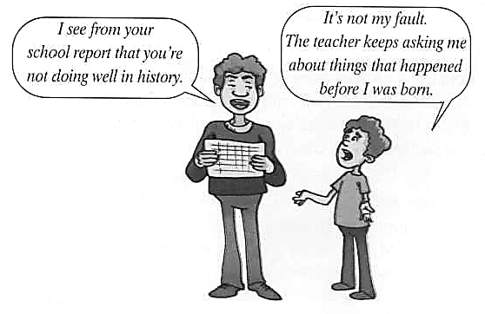

**b. What kind of career do you think Joe might choose later on in life? Put a tick (✓) or cross (X) by the careers below.**

❑doctor ❑ singer/composer ❑ artist

❑journalist ❑ computer programmer ❑ scientist

❑accountant ❑ translator ❑ P.E. teacher

**Discuss Joe's future career in pairs, giving reasons for your decisions.**

e.g.: *I think Joe might become a journalist because he is very good at languages.*

1. **Talk about your favourite and least favourite subjects as in the example.**

*I really enjoy physical education because it’s fun and it keeps us fit. However, 1 don’t really like physics because 1 find it difficult.*

1. **Complete the timetable with the subjects from exercise 5.**
2. Monday 9.00-9.45: the study of the methods and activities of teaching
3. Monday 9.45-10.30: the study of drawing and painting
4. Monday 10.30-11.15: the study of the past
5. Monday 11.15-12.00: the study of numbers, shapes, etc.
6. Tuesday 9.00-9.45: the study of the human mind and feelings
7. Tuesday 9.45-10.30: the study of sounds made by instruments or voices
8. Tuesday 10.30-11.15: the study of the use of computers for sending and storing information
9. Tuesday 11.15-12.00: doing exercise and learning to play sport
10. Wednesday 9.00-9.45: the study of countries, rivers, mountains, etc.
11. Wednesday 9.45-10.30: the study of books, plays, poems, etc.
12. Wednesday 10.30-11.15: using experiments for the study of the way things happen in the physical world
13. Wednesday 11.15-12.00: the study of the language people speak in Britain

|  |  |  |  |
| --- | --- | --- | --- |
|  | Monday | Tuesday | Wednesday |
| 9.00-9.45 |  |  |  |
| 9.45-10.30 |  |  |  |
| 10.30-11.15 |  |  |  |
| 11.15-12.00 |  |  |  |

1. **Fill in your own timetable for today as in the example:**

|  |  |  |
| --- | --- | --- |
| Day of the week |  | |
| 08:30-10:05 |  | Classroom ____ |
| 10:15-12:05 |  | Classroom ____ |
| 12:05-12:25 | Break and lunch | Canteen |
| 12:25-14:00 |  | Classroom ____ |
| 14:05-15:40 |  | Classroom ____ |

1. **Fill in the correct word.**
2. I could get a job as a secondary school ………. now, but I want to continue studying to become a university ……… . (teacher / lecturer)
3. History is my favorite ………, but today's ……… wasn't very interesting. (lesson / subject)
4. My primary school only has 300 ………… but there are over 5,000 ………… at my brother's university. (pupils/students)
5. Frank got good ………… in all of his school exams, so he was able to go to university to do a ………… .(grades /degree)
6. There will be no lectures during the last ………… of my history ………… as we are expected to study for exams then. (course / term)
7. I got an extra ………… for remembering the name of Napoleon's horse, so my final ………… for the test was 19 out of 20! (point / mark)
8. The ………… of the arts faculty used to be the ………… of a primary school. (dean / headmaster)
9. When I went to …………… I only saw my parents during the holidays, but now that I go to a ……………I see them every night. (day school / boarding school)
10. It is necessary to pay school fees in order to go to a ………… whereas a ………… is run by the state and is therefore free. (comprehensive school / private school)
11. My brother and sister go to a …………… but I go to a …………… where there are only girls. (co-educational school / single-sex school)
12. **Fill in the gaps with the correct preposition.**
13. Only one pupil put ………… her hand to answer the question.
14. I wasn't paying attention ………… what the teacher was saying so I couldn't answer her question.
15. She studied for three years to get a degree ………… biology.
16. Students should not be punished ………… making mistakes.
17. You have to be good ………… science and maths if you want to be an astronomer.
18. John wrote an essay ………… the effects of air pollution.
19. He bent down to pick ………… the books he had dropped.
20. We had to learn the definitions of the words ………… heart for the exam.
21. He looked at the information ………… the computer screen to find the answer.
22. **A. Write these words in the correct column.**

a certificate pedagogy a degree a diploma secondary school ~~high-school~~  psychology literature primary school university

|  |  |  |
| --- | --- | --- |
| go to + place, leave + place | study + subject | get + qualification |
| *high school* |  |  |

1. **Add more words. Use your dictionary.**
2. **Grammar focus. Put the verbs in brackets into the present simple or the present continuous.**

Hi Isabel,

I'm in the beautiful city of Oxford. I 1) ..*am studying..*(study) German and Russian at the university here. I 2) ………. (find) both languages interesting but German 3) ………. (be) more difficult. All the other students on the course 4) ………. (feel) the same way, too. We 5) ………. (meet) once a week to discuss the lectures. This week, we 6) ………. (go) to the theatre in London to see a play.

I 7) ………. (stay) on the campus for the moment but a few of us 8) ………. (look) for a house to share. The food in the canteen 9) ………. (not/be) very good, so we usually 10) ………. (have) lunch at a restaurant nearby.

I hope to hear from you soon.

Take care,

Bill

1. **Game. Can you find 16 hidden words in this word search? Words can go in the following directions: ▲►▼◄.**

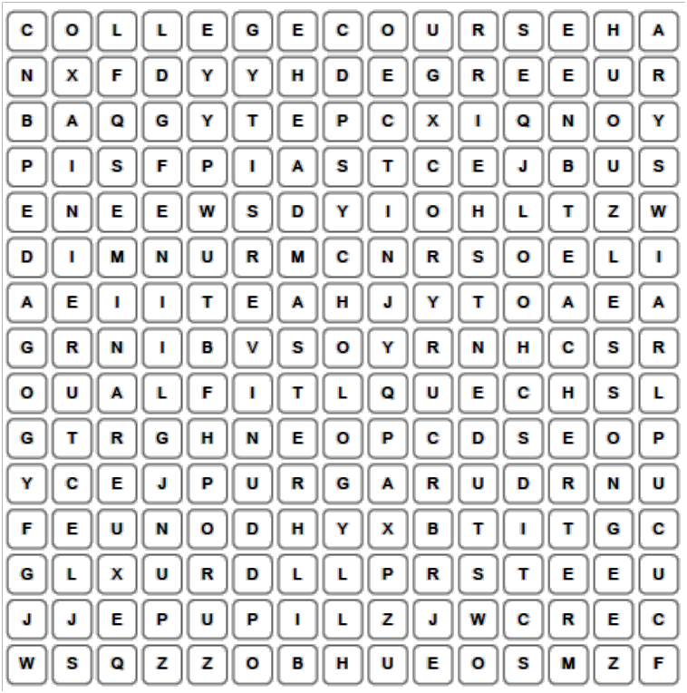

**Unit 2. STUDYING AT COLLEGE/UNIVERSITY**

1. **Answer the questions about yourself.**
2. Why did you enter this college?
3. How many departments are there in our college? What are they?
4. What department do you study at?
5. Why did you choose this specialty?
6. What year are you in?
7. What group do you study at?
8. What is your group mistress?
9. What is your head girl?
10. **Complete the questions using the words in the box. Then answer them.**

assessment ~~group~~ coursework department grade homework lessons marks revising staff

1. How many students are there in your …..…? ……*group*……
2. How many members of ………. are there at your ...……………..

college?

1. What is the name of the head of your …………? ...……………..
2. How many …………do you have each day? ...……………..
3. How many ………. did you get in your last ...……………..

English test?

OR

What was your ………. in your last English test? ...……………..

1. How long does it take you to do your …………. ...……………..

each night?

1. Which do you prefer: exams, continuous ……….. ...……………..

or a mixture of the two?

1. Do you like to have music in the background when you ...……………..

are ………. for an exam?

1. Which are you better at: exams or ……….? ...……………..
2. **Read the text “At my college”.**

**At My College**

Alexei is going to leave school in a year, but he realizes that he must start thinking about further education right now, because it is essential to read for exams well beforehand. So he asks his brother to tell him about his college and advise.

**Alexei:** Vlad, I want to ask you about college life. Is it different from school life?

**Vlad:** Well, it depends on what you are interested in. We, too, in college have lessons, and marks; teachers give us homework, and there are examinations and tests.

**Alexei:** Well, I see. But, then, is there any difference between a school and a college?

**Vlad:** Why, of course. First, at college we have special subjects in our curriculum. For example, if one is going to be a teacher, he or she will take pedagogy, psychology, and methods of teaching. If one wants to become an economist, he or she will study economics, accounting, taxation and a lot of other things. It’s really very interesting. Second, if you work regularly, attend all the lectures and seminars, and get good marks, you will be given a scholarship. If you are at the top of the group, and have excellent marks, the scholarship will be higher.

**Alexei:** It sounds very nice, I must say. Now, please, describe your usual day at college.

**Vlad:** Well, our day starts in the assembly hall, where we all gather together and the head teacher calls the register. Then the classes begin. We have several lectures and seminars every day, and work in workshops. Students also can stay at college after classes to do research.

**Alexei:** How are students assessed?

**Vlad:** We have exams and credit tests twice a year. But of course, it is important how you work during the year.

**Alexei:** What is the difference between an exam and a credit test?

**Vlad:** Well, you get marks for an exam, and when you take a credit test, you’ll get a “pass”. Exams are usually taken at the end of the course of a subject. For example, if you take chemistry for a year and a half, you will have credit tests in chemistry at the end of two terms, and at the end of the third term you will take an exam.

**Alexei:** Is an exam more difficult, than a credit test?

**Vlad:** Not really. In fact, you have more time to read for an exam: you are given from two to five days to get ready, and you are not given a lot of time to get ready for a credit test. In general, it depends on the subject.

**Alexei:** Well, I see. Now, what about holidays? They are not the same as at school, are they?

**Vlad:** We have holidays only two times a year: two weeks in February and two and a half months in summer.

**Alexei:** Vlad, what are you going to do after you graduate?

**Vlad:** There is a good opportunity for those who get only excellent marks while they study. When we graduate, we can enter a university without taking entrance exams and continue our education there. That’s why I study hard and try to work regularly, and not by fits and starts. And hard work gives good results, as I am at the top of the group now.

**Alexei:** The prospect is very nice. I wish you good luck, then. Do you advise me to enter this college, too?

**Vlad:** You know, it’s up to you to decide. But I like my studies there, and I think I have made the right choice. Besides, I’ve got many friends in the college, and friendship is the best thing in the world!

1. **Find in the text English equivalents for the following Russian sentences.**
2. К экзаменам необходимо готовиться заранее.
3. В колледже есть специальные дисциплины в учебном плане.
4. Если кто-то собирается быть учителем, он или она будут изучать педагогику, психологию и методы обучения.
5. Если ты будешь получать хорошие отметки, то ты будешь получать и стипендию.
6. Наш день начинается в актовом зале.
7. Два раза в год у нас экзамены и зачеты.
8. Мы можем поступить в университет, не сдавая вступительных экзаменов.
9. Я сейчас лучший в группе.
10. **Decide whether the following statements are true or false.**
11. Alexei is studying at college.
12. In college Vlad has lessons, and marks and teachers give him homework.
13. If you are at the top of the group, the scholarship will be lower.
14. Students’ day starts in the canteen, where they all gather together.
15. Students also can stay at college after classes.
16. Vlad has exams and credit tests once a year.
17. There is no difference between an exam and a credit test.
18. Vlad has holidays only in February and in summer.
19. Vlad isn’t going to enter a university and continue his education there.
20. Vlad thinks he has made the right choice.
21. **Use words from the text ‘At My College’ and translate into English.**

Занятия в колледже обычно продолжаются до четырех часов. Работать следует регулярно, чтобы учиться успешно. Те, кто хорошо учатся, полу­чают стипендию. Кроме того, студенты, успешно окончившие колледж, имеют возможность поступить в институт или университет, сдав только один экзамен. В учебном году два семестра. В конце каждого семестра студенты сдают зачеты и экзамены.

1. **Fill in the gaps with *do*, *make* or *take*. Make 5 sentences with these expressions.**
2. ______ an exercise
3. ______ an exam
4. ______ an effort
5. ______ one's best
6. ______ a break
7. ______ notes
8. ______ mistakes
9. ______ an assignment
10. **Match items from columns A and B to make idioms and then use them, in their correct form, to complete the sentences.**

|  |  |
| --- | --- |
| **A** | **B** |
| **1** be the teacher's | **a** p's and q's |
| **2** mind one's | **b** one, two, three |
| **3** learn something | **c** the grade |
| **4** be as easy as | **d** pet |
| **5** be of the | **e** the back of one's hand |
| **6** know something like | **f** old school |
| **7** pass with | **g** by heart |
| **8** make | **h** flying colours |
|  |  |

1. Now Johnny, if you're coming to see your sister in the school play you're to be quiet and ___________________.
2. 2 I can remember as a child, the difficult time I had learning my multiplication tables ___________________.
3. Don't mind your father. He ___________________ and believes that some jobs are just not meant to be done by a man.
4. The children jeered their classmate in the school yard with the cruel chant of, ‘Suzy ___________________!’
5. Everybody here is fine and Steve has just finished his finals which he ___________________.
6. If you don't study harder there is no way that you will ___________________.
7. I've been studying this list of historical dates for hours and I ______________.
8. There's nothing to geometry, it ___________________.
9. **Grammar focus. Think of the rules at your college. Use the Key Words to talk about what you *can* and *can't do*, and what you *have to* and *don't have to do*.**

e.g.: *We* *have to change our shoes when we come in.*

*Key Words*

change your shoes, smoke, wear a uniform, kiss, eat during lessons, use notes during tests, play music during breaks, be late for lessons, go on class excursions, wear make-up, tie long hair, organize discos, wear jeans, listen to music during lessons

**Discuss the rules with your group. How tolerant is your college?**

1. **Grammar focus.Complete the text with suitable modal verbs. There may be more than one answer.**

**Milton School. Exam Rules**

1. You … *must*… bring your student ID card with you to the examination.
2. You ………… put it on your desk so that your teacher can see it.
3. You ………… talk during the exam.
4. When you finish your exam, you ………… quietly leave the exam room.
5. You .………… use a calculator for the Mathematics section.
6. You ………… be in the exam room at least 10 minutes before the exam starts.
7. You ………… turn off your mobile phone during the exam.
8. You 8) ………… take your books with you into the exam room.
9. **Put the words and phrases in three columns.**

test, quiz, written exam, finals, entrance exam, sit an exam, exam questions, computer-based exam, internet-based exam, take an exam, oral exam, pass an exam, exam board, pen and paper exam, fail an exam, exam results, study for an exam, exam papers, read for an exam, exam supervisor

|  |  |  |
| --- | --- | --- |
| **types of exams** | **students’ exam related actions** | **exam related people or things** |
|  |  |  |

1. **a. Are exams fair or not? Tick the statements you agree with.**

|  |  |
| --- | --- |
| **YES**  □ The alternative to sit-down exams is to do coursework over the whole school year. This gives students the opportunity to cheat. They can copy other people’s work, for example. | **NO**  □ You might have hay fever or feel sick on the day of an exam, and so you do badly. That's unfair. |
| □ Continuous assessment isn't fair. Students who have their own room to study in and access to books and computers at home have a much better chance of success than students who don’t have those things. | □ Exams are a test of memory. They don’t test how much you really know. |

**b. Write your own reason for being in favor of or against exams.**

…………………………………………………………………………………………………………………………………………………………………………………………………………

……………………………………………………………………………………………………

……………………………………………………………………………………………………

1. **Answer the questions.**
2. What professions can you master in vocational colleges?
3. What is the main difference between vocational colleges and universities?
4. **Read the text and check your guesses.**

Contrary to popular belief, vocational colleges aren’t just for students who couldn't get into university. Students attend vocational colleges for a number of reasons, including getting some practical skills or experience before going to university. For many people it is a good two-year long alternative to longer higher education programs.

Whereas in universities the education concentrates more on theory and abstract knowledge, in vocational colleges the education usually prepares learners for careers that are traditionally non-academic. In other words, it is directly related to a specific occupation or vocation, and students develop expertise in a particular technique or learn some practical skills.

Till the end of the twentieth century, vocational education focused more on specific trades, such as automobile mechanics or welding, and was therefore associated with the activities of lower social classes. But the situation has changed. Now vocational education exists in industries such as retail, tourism, information technology and cosmetics.

*(Enjoy English 11)*

1. **Do research on the internet of a successful person who didn’t go straight to a university after school. Present the results of your research to the rest of the group.**
2. **Be ready to participate in a conversation on the Module 1.**
   1. What year are you in now?
   2. When will you graduate?
   3. How many students are there in your group?
   4. Did you take any entrance exams to your college? What exams did you take?
   5. What are you going to do after you graduate?
   6. Do you get a scholarship?
   7. Do any of your friends live in a hostel?
   8. How often do you have exams and credit tests?
   9. Are you always in time for classes?
   10. Do you work regularly or by fits and starts?
   11. How long does it usually take you to read for an exam?
   12. Do you ever miss classes?
   13. When do the students of the college gather in the assembly hall?
   14. Do the students in your college have to wear a uniform?
   15. What are your favorite subjects?
3. **Write an essay “At My College” (150-180 words).** Use your answers on the questions from ex. 1 and ex. 13.
4. **Write ten words and five expressions you are going to memorize.**

|  |  |
| --- | --- |
| **Words** | **Expressions** |
| 1. | 1. |
| 2. |
| 3. | 2. |
| 4. |
| 5. | 3. |
| 6. |
| 7. | 4. |
| 8. |
| 9. | 5. |
| 10. |

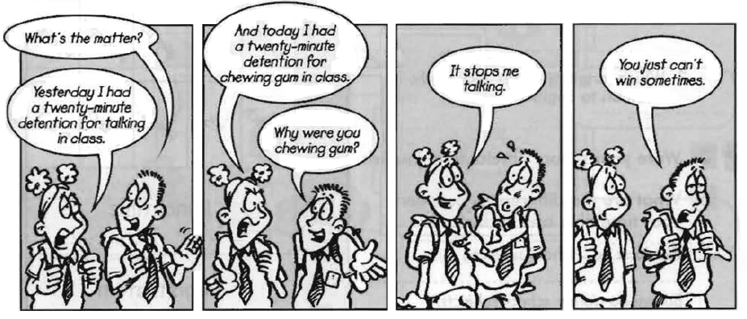**MODULE 2. AT THE LESSON**

**Unit 1. FIRST LESSON**

1. **Before you start working at the text practice pronunciation of the following words. Transcribe them, guess the meaning. Read aloud.**

|  |  |  |
| --- | --- | --- |
| chorus  obediently  obey  silent | term  conscious  yelp  tongues | headmistress  innocent  imperative  note |

1. **Read the text.**

**ANNE MEETS HER CLASS**

The children fixed their eyes upon Anne. Anne gazed back, **feeling helpless**.

Now, children,” began Miss Enderby firmly, “you are very, very lucky this term to have Miss Lacey for your new teacher.”

Anne **gave a watery smile**. The children's faces were **unmoved**.

“Miss Lacey,” repeated Miss Enderby with emphasis. “Can you say that?”

“Miss Lacey,” chorused the class **obediently**.

“Perhaps you could say ‘Good morning’ to your new teacher?” suggested Miss Enderby **in an imperative tone**.

“Good morning. Miss Lacey,” came the polite chorus.

“Good morning, children,” responded Anne in **a voice which bore no resemblance to her own**.

Miss Enderby motioned to the children to take their seats. She gave a swift look round the class. “I expect you to help Miss Lacey in every way,” said the headmistress. “Do you hear me, Arnold?”

The little boy addressed, who had been **crossing and uncrossing his eyes** in an ugly manner for the enjoyment of his neighbours, looked **suitably crest-fallen**.

“If I were you, I should keep an eye on that boy,” murmured Miss Enderby. “Broken home — brother in Borstal —and some rather **dreadful habits**!”

Anne looked with fresh interest at Arnold and thought he looked quite different from what Miss Enderby said about him. He looked **innocent** and apple-cheeked. But even as she looked, she saw his pink face express his **scorn** of Miss Enderby.

She made her way to the door and waited before it, eyebrows raised as she turned her gaze upon the children. They gazed back **in some bewilderment**.

“Is no one going to remember his manners?” asked Miss Enderby.

With a nervous start Anne hastened forward to the door, but was waved back by a movement of her headmistress's hand. A dozen or more children made a rush to open the door. A freckled girl with two skinny red plaits was the first to drag open the door. She **was rewarded by a smile**.

“Thank you, dear, thank you," said Miss Enderby and sailed majestically into the corridor. There **came a faint sigh of relief** as the door closed behind her, and **the forty-six tongues which had so far kept unnaturally silent began to wag cheerfully**. Anne watched this change with some **dismay**. She remembered some advice given her at college.

“**Stand quite still, be quite calm, and gradually the children will become conscious that you are waiting. Never, never attempt to shout them down**.”

So Anne **stood her ground** waiting for the chattering to subside. But **the noise grew in volume**. One or two children ran across the room to see their distant friends. Two little boys attacked each other. Amidst growing chaos Anne **remained silent**. **Her presence**, she noted, **meant nothing at all** to them.

A chair fell over, someone yelped with pain, there was a burst of laughter, and Anne couldn’t wait anymore. “To your desks!” she **roared**, "And quickly!”

With a pleasurable shock she saw **her words obeyed**. Within a minute order had returned and the children turned attentive eyes upon her.

*(Fresh from the country by Miss Reed)*

1. **Translate into Russian words and word combinations in bold.**
2. **Answer the questions.**
3. How was Anne introduced to her class?
4. What did she feel at that moment?
5. Why did Anne “look with fresh interest at Arnold”?
6. How did the other children behave in Miss Enderby’s presence? (Find words describing their behavior.)
7. Why do you think “there came a faint sigh of relief” after Miss Enderby left the classroom? Describe the children's behavior after she left.
8. What advice given her at college did Anne remember? Did she follow the advice? What was the result? Why did the children behave like that?
9. How did Anne restore the order? Do you think it was the only way out? What would you do?
10. **How did you usually behave at the lesson? Did you like to attend lessons? What sort of child were you? Draw you portrait and write down a sentence using 3-5 adjectives to describe yourself at primary school.**

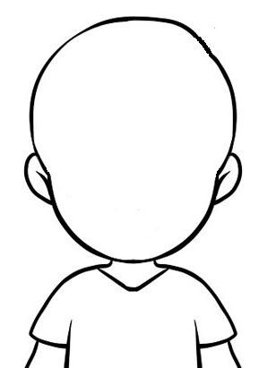

I was ……………………………………………………… …………………………………………….…………………

**Can you use the same words to describe yourself today?**

1. **Read the article and answer the questions.**

**Bringing up children**

There is no doubt that disorderly behavior, breaking of rules interfere with class teaching. The most common examples of misbehavior are, for instance, the cases of rudeness, making noise and disturbing others, spoiling school property.

There are different ways of punishing children who break discipline, but one principle should be followed and that is tact, understanding a child's nature.

In all cases of misbehavior the pupils' parents are communicated with.

All cases of discipline violation are marked in the pupils' day-books, which the parents must sign.

Parents are called to school when necessary. Only after all methods of persuasion we tried we resort to some form of punishment. However, the use of any kind of physical punishment is forbidden in our schools under any circumstances. Parents should manage very well without it too. Whipping and unfair treatment may develop in a child such traits of character as rudeness, cruelty, indifference to others.

1. What can interfere with class teaching at school?
2. What are the most common examples of misbehavior?
3. How can schoolchildren be punished?
4. What must teachers and parents bear in mind when they punish children?
5. Any kind of physical punishment is forbidden in our schools. Why?
6. Do you agree that very often methods of persuasion are enough to make the child mend his conduct?
7. **Substitite words in italics by some word or expression from the text**.
8. His ill-breeding disturbs teachers and his classmates.
9. Damaging one’s property is a serious case of breaking discipline.
10. Corporal punishment isn't yet forbidden in some English schools.
11. When are parents contacted with?
12. This little boy is always showing roughness.
13. **Speaking. Give answers to the following questions.**
14. How were you brought up in the family?
15. What traits of character can a child develop if he is beaten or humiliated?
16. How must the parents react if their children play pranks?
17. What do you think about encouraging and rewarding children?
18. Who do you think may be considered ideal parents?
19. **Read the text “Why do I have go to school?”**

I don't understand why I have to go to school. Mom says that I need to leant things I’ll use in my professional life, but who cares? I don’t want to be a doctor or a lawyer... In fact my dream is becoming a great soccer player and play soccer in many countries around the world. Why would I need to go to school to do that? Well, I’ve been thinking... Maybe I'll need to learn some languages or I'll never be hired to play abroad. And if I become rich I’ll need to know some maths to deal with so much money... And I'll have to understand contracts. Some geography wouldn’t be bad alter all...You know what? Maybe Mom is right and if you want to be a doctor, a lawyer or a soccer player like me you’ll have to go to school and study hard. I’ve got to go now, I’ve just remembered I've got some homework to do and I don't want to risk my brilliant future. From now on. I’ll do my best to learn everything I can.

1. **Mark true (T) or false (F). You'll explain when it's false.**
2. The boy thinks a soccer player doesn't have to go to school. ( __ )
3. His mother agrees with him. ( __ )
4. He wants to be a lawyer or a doctor. ( __ )
5. He realizes he needs to learn some languages. ( __ )
6. He thinks geography won't be useful. ( __ )
7. Maths can help him in the future. ( __ )
8. He doesn’t have homework to do. ( __ )
9. Now he thinks doing homework is important. ( __ )
10. **Mark if you agree (A) or disagree (D) with the boy.**
11. Soccer players don’t need to study. ( __ )
12. To work in other countries you have to know their language. ( __ )
13. Rich people need to know math to deal with business. ( __ )
14. Geography can help if you’re going to travel around the world. ( __ )
15. If you don’t do your homework you might risk your future. ( __ )
16. You should do your best to learn everything. ( __ )
17. **Answer the questions:**
18. Did you have some problems with motivation to learn at school?
19. How do you think knowledge received at school and at college will help you in the future?
20. What subjects do you think will be the less important for you in the future? Why?
21. **Speaking. Read the dialogue ‘Teaching Practice’ between students of a Teacher Training college and answer the questions.**
22. **Diana**: Philip! Philip! We're over here.

**Caroline**: What happened to you?

**Philip**: Nothing very much.

**Diana**: Well, why are you late then?

**Philip**: I left the address of the school in my other jacket.

**Caroline**: I don't know how you'll get through your teaching practice.

**Philip**: Oh, I'll manage. I always do. I've planned all my lessons. I'll be superb.

**Caroline:** You're the most conceited man I've ever met.

**Philip**: What school are you going to, Steve?

**Steve:** A school in Hillingdon. Brook Lane Secondary School.

**Philip**: Brook Lane! I've heard some pretty ghastly things about that place.

**Steve:** Oh? What's wrong with it?

**Philip**: You'll find out. I'm glad I'm going to work with Juniors.

**Steve:** You still haven't told me what's wrong with Brook Lane.

**Philip**: Oh, it's only that my tutor said –

**Caroline**: Don't listen to him, Steve, he's only trying to frighten you.

**Steve:** What did your tutor say?

**Philip**: Nothing much. Well, I must dash! See you tonight!

1. **Diana**: How did you get on, Steve?

**Steve:** Very well indeed! I had this marvelous idea about drama.

**Diana**: What were you doing?

**Steve:** It was a history lesson actually. I was doing something about Roman Britain.

**Caroline**: Roman Britain? What has the drama to do with it??

**Steve:** Well, we'd talked about Caesar's invasions of Britain and I thought we'd act the assassination. Marvelous idea! The whole class were Roman Senators and I was Caesar. Action, everything. It was all right until one of the kids produced a real knife! Here's Philip.

**Caroline**: Late again!

**Philip**: I had to wash my trousers.

**Diana**: You had to wash your what?

**Philip**: Trousers! They were covered in powder-paint.

**Diana**: Well, what's been happening to you?

**Philip**: An art class! I told them to paint me. And one of them did! All over! Then the Headmaster came in.

**Steve:** I bet he was furious.

**Philip**: No, no, on the contrary. He said, "Congratulations, Mr. Webster. We've had such a lot of trouble with that child. This is the first time he's done anything!"

(*Modern English*)

**Questions on the dialogue**

**a)** 1. A group of English students were going to have some teaching practice. What were their names? 2. Why was Philip a little bit late? 3. Why wasn't Caroline sure that Philip would get through his teaching practice successfully? 4. Why did Caroline call Philip the most conceited man she had ever met? 5. What school was Steve going to? 6. What was the reputation of that school? 7. Why didn't Philip tell Steve what was wrong with that school? 8. Why didn't Caroline allow Philip to tell Steve what he knew about that school?

**b)** 1. How did Steve get on with his practice? 2. What marvelous idea did Steve have at the lesson? 3. Was it a history lesson or a music lesson? 4. What did Steve tell the children about? 5. Who suggested the idea of acting the assassination? 6. Who were Roman Senators and who played the part of Caesar? 7. Did the children take the play seriously? Why do you think so? 8. Did the children confirm the reputation of the school? 9. Why was Philip late again? 10. Why did he have to wash his trousers? 11. How did it happen that Philip's trousers were covered in powder-paint? 12. What did the school headmaster congratulate Philip on? 13. Did Philip's juniors prove to be quiet and obedient as he had hoped?

1. **Acting the dialogues. Exchange opinions with your partner about the teaching practice you have had.**
2. **Write a composition “My First Teaching Experience” (150-180 words).** Study Appendix (p. 57) and describe your first lesson at school as a teacher.

**Unit 2.UNUSUAL LESSONS**

1. **Read the title of the article. What do you think it is?**
2. **Read the text and complete the sentences. Use up to three words.**
3. Students in Australia attend the School of the Air because their families live far……….. .
4. The children of this school have their lessons over ………… .
5. The children belong to a class, but they study ………….. .
6. Each lesson lasts ………… .
7. Students send their homework …………. .
8. The teacher usually meets the students ……….. .

In Australia, many families live a long way from a town, so the nearest school is often very far away.

For this reason, many children attend a very different kind of school. It is called the School of the Air because the students have lessons over the radio.

Most areas have a school like this for children between 4 and 12 years old. They study at home, but they are still members of a class. The children have radio lessons with their class three times a week. Each lesson is about 30 minutes. Students also have a 10-minute private lesson with their teacher once a week.

The school provides the radio, books, videos and other resources. The children send their work to the teacher once a week. The teachers prepare the lessons and the children's parents help them to do their work at home. Teachers and students also communicate by phone, fax and email and the teacher visits children at home at least once a year.

The School of the Air may sound like a strange idea. For the isolated students of Australia it's the only way to learn.

*(Upstream. Elementary)*

1. **Find information about a school in your country that is different from typical schools and write a short description of it. Write:**
2. how the school is different from other schools
3. how many days a week/hours a day students attend
4. what subjects they study
5. **Grammar focus. Rewrite the following passage in the passive.**

Our school is organising a Science Fair. The headmaster will choose the best project. The teachers have asked students to do something about the environment. Students should include interesting experiments in their projects. The school will give the winners a set of Science books.

*A Science Fair is being organized by the teachers of our school.* ………………………………………………………………………………………………………………………………………………………………………………………………………………………………………………………………………………………………………………………………………………………………………………………………………………………………………………………

………………………………………………………………………………………

………………………………………………………………………………………

1. **What methods or technologies are you going to use at school to make your lessons unusual?**
2. **Read the text as the material for the topic "Games in Children's Life".**

**The Role of Play at the Lesson**

Children grow, learn and even investigate the world through play. Play is the basis for discovery, reasoning and thinking. When children are given the freedom to experiment, to make mistakes and then to learn from these mistakes, they are developing skills that will stay with them for life.

Children do not differentiate between play, learning and work. Children are playful by nature. They love to play because play is an activity in which any child is open to express his points of view, ideas and thoughts.

It is important to notice that games are necessary not just for junior pupils; in senior forms the elements of the play must be included into the educating process. So games vary accordingly to the age of children.

In primary school the lesson is a game itself. All the material is given in the form of play: different puzzles, crosswords, different competitions, creative activities, which do not only stimulate children's imagination, but also develop skills such as hand-eye coordination.

In secondary and higher schools games become more intellectual and scientific. They can be different projects on actual problems, role-playing, round tables, intellectual quizzes, some creative activities and team competitions.

In any case, we can't teach and educate without plays.

1. **Put questions to the text and ask your partners to answer them.**
2. **Discuss the statements.**
   1. Children are always ready to learn, but they don't like to be taught.
   2. One of the secrets of the experienced teacher is to keep children's intellectual curiosity through play.
   3. The best way to get along with children is to give them good cheer and amusement.
3. **What types of plays and games do you know?**
4. **What is the role of playing at the lesson?** Complete the following word combinations.

to investigate ______________________, to develop ______________________,

to be free to express ___________________, to educate ____________________,

to stimulate __________________, to help children to _____________________.

1. **A Game always makes a lesson unusual. It is “Word Hunt”. Students can either work individually, in pairs or in small groups.**

**A. Make a list of everything in the classroom. Who has the longest list?**

**B. Name at least two things in the classroom that:**

1. are very expensive:
2. you can use to write with:
3. are small enough to fit in your pocket:
4. you would find it difficult to study without:
5. are brown:
6. are very heavy:
7. won’t work without electricity:
8. are made of glass:
9. cost less than a pound:
10. **Unscramble all the words.**

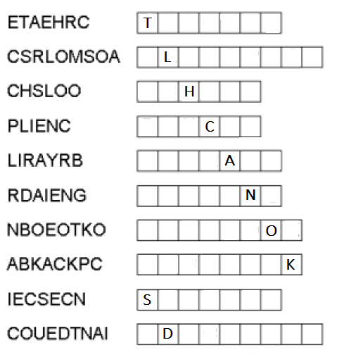

1. **Guess and translate the proverbs.**

Achildwithouteducationislikeabirdwithoutwings.

____________________________________________________________

____________________________________________________________

Educationisagiftthatnonecantakeaway.

____________________________________________________________

____________________________________________________________

1. 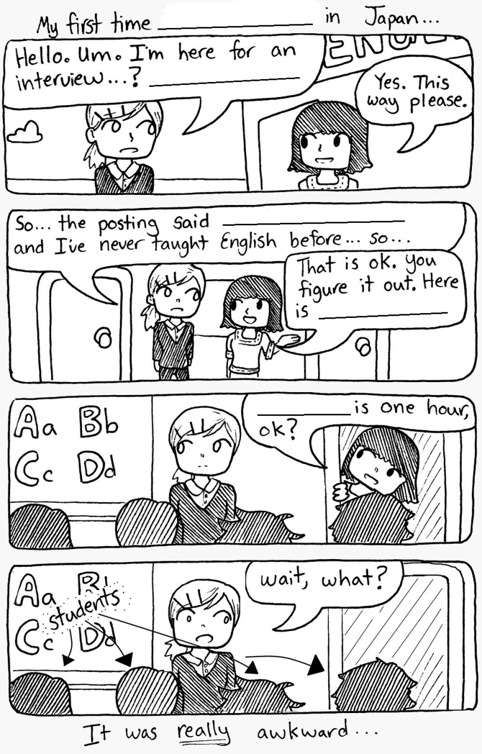**Complete the comic using the phrases given below.**
2. experience isn’t necessary
3. teaching English
4. The lesson
5. To be a teacher.
6. your classroom.
7. **Write ten words and five expressions you are going to memorize.**

|  |  |
| --- | --- |
| **Words** | **Expressions** |
| 1. | 1. |
| 2. |
| 3. | 2. |
| 4. |
| 5. | 3. |
| 6. |
| 7. | 4. |
| 8. |
| 9. | 5. |
| 10. |

**MODULE 3. TEACHER’S PROFESSION**

*If all the good people were clever,*

*And all clever people were good,*

*The world would be nicer than ever…*

*(Elizabeth Wordsworth)*

**Unit 1.CAREER PLANS**

1. **Complete this brain-teaser chart: figure out one job that starts with each letter of the alphabet.**

|  |  |  |  |
| --- | --- | --- | --- |
| **A** |  | **N** |  |
| **B** |  | **O** |  |
| **C** |  | **P** |  |
| **D** |  | **Q** |  |
| **E** |  | **R** |  |
| **F** |  | **S** |  |
| **G** |  | **T** | a teacher |
| **H** |  | **U** |  |
| **I** |  | **V** |  |
| **J** |  | **W** |  |
| **K** |  | **X** |  |
| **L** |  | **Y** |  |
| **M** |  | **Z** |  |

1. **Whose job do these things belong to?**

e.g. bucket, ladder, leather – *window cleaner*

1. board, overhead projector, chalk
2. make-up, script, microphone
3. scalpel, mask, forceps
4. tractor, plough, barn
5. fax machine, filing cabinet, stapler
6. sewing machine, scissors, needle
7. **Match these job characteristics with their definitions.**

|  |  |
| --- | --- |
| 1. well-paid | a) giving pleasure and joy |
| 1. stressful | b) giving satisfaction and profit |
| 1. challenging | c) dull and tiresome |
| 1. enjoyable | d) extremely irritating and often overwhelming |
| 1. boring | e) difficult and complex |
| 1. rewarding | f) stimulating, interesting and thought-provoking |
| 1. complicated | g) meeting all requirements and conditions |
| 1. satisfying | h) awarding enough money |

1. **A. Which of the adjectives below and in Ex. 3 can describe the job of a lawyer, a writer, a teacher, a detective and a programmer? Give reasons**.

• interesting • exciting • dangerous

• relaxing • difficult • demanding • tiring

*I* *think a _________'s job is interesting because they ____________.*

**B. Which qualities are necessary for each job?**

• intelligent • brave • physically fit • calm

• reliable • friendly • patient • polite

• creative • imaginative • skillful • caring

*A _______ needs to be _______, _______ and ________.*

1. **Game. Use the phrases below to tell your partner three facts about one of the jobs. Your partner has to guess the job.**

travel a lot

work part-time

get good salaries

work outdoors

use a computer

work 9 to 5

start early in the morning

work shifts

work indoors

work long hours

wear a uniform

work with their hands

e.g.: A:*They usually work 9 to*5. *They use a computer. They don't work outdoors.*

B: *Are they secretaries?*

1. **Grammar focus.Look at the list of jobs and write some more you would like to do. Complete the table with activities people have to/don’t have to do in these jobs.**

|  |  |  |
| --- | --- | --- |
| Do you want to be a … ? | Have to ... | Don’t have to ... |
| Teacher |  |  |
| Photographer |  |  |
| Secretary |  |  |
| Shop assistant |  |  |
|  |  |  |
|  |  |  |

In groups, order the jobs from 1 - 6 in order of preference. (1 = the best, 6 = the worst). Tell the other groups your reasons.

1. **Answer the questions:**
2. What are your career plans? What sort of job interests you?

*I'd like to*…………………………………………………………………………

1. What do your friends and family think about your choice?

…………………………………………………………………………………...

1. What interests do you have which make you suitable for this kind of work? …………………………………………………………………………………..
2. What experience do you have which makes you suitable for this kind of work? ……………………………………………………………………………
3. What kind of job would you least like to have? …………………………….
4. What jobs, if any, do you think should only be done by men/women? …………………………………………………………………………………..
5. What’s more important to you – earning lots of money or having a job you enjoy? …………………………………………………………………………..
6. **Imagine you have worked in your chosen job for a year. You're talking to some students who are thinking of doing the same job as you. Answer their questions.**
7. What qualifications do you need? …………………..………… ……………

…………………………………….…….…………………………….…………

1. What sort of a person do you need to be? ……………………………………

…………………………………….…….………………………….……………

1. What about training? …………………………………………………………

…………………………………….…….…………………………..……………

1. What are the hours? …………………………………………………….…….

…………………………………….…….…………………………..……………

1. What's the money like? ………………………………………………………

…………………………………….…….………………………..………………

1. What's the best bit about the job? ……………………………………………

…………………………………….…….…………………………..……………

1. What's the worst bit? …………………………………………………………

…………………………………….…….……………………….………………

1. **Jane Anderson has filled in this application form (a form that you complete in order to apply for a job). You have her answers. Can you finish the form? Use the words from the box.**

~~Family name~~ Interests Tel. no. Education: schools attended

Signature Marital status Languages spoken Previous experience

First names Place of birth Education: university/college

Mr/Mrs/Miss/Ms Date available Date Present address Children Driving licence Present position Date of birth Present salary

|  |  |  |  |  |
| --- | --- | --- | --- | --- |
| **THE APPLICATION FORM**  Please type or write clearly | | | | |
| 1. *Family name* | Anderson | | 1. ……… | Ms |
| 1. ………… | Jane Irene | | 1. ……… | 584-29-01 |
| 1. ………… | 30th July 1961 | | 1. ………… | York |
| 1. …………… | Single | | 1. …………. | None |
| 1. ………………….. | | 27 Greenhill Gardens, Richmond, Surrey | | |
| 1. ………………….. | | York Girls’ School ’72-‘79 | | |
| 1. ………………….. | | Rayon College of art ’79-‘83 | | |
|  | | Diploma in Art and Design (Dip AD) ‘83 | | |
| 1. …………………. | | Art and Craft Summer School (Assistant Teacher)  Spain ’83 + ‘84 | | |
| 1. ………………….. | | Art Department, J.Y.C. Magazine | | |
| 1. ………………….. | | £8,500 p.a. | | |
| 1. ………………….. | | French and Spanish, German (a little) | | |
| 1. ………………….. | | Yes | | |
| 1. ………………….. | | Photography, Astronomy, Mountain Climbing | | |
| 1. …………………… | | From January 1st ‘86 | | |
| 1. …………..……….. | | Nov 15th ‘85 | | |
| 1. …………………… | | Безымянный.jpg | | |

1. **Write your personal Application form. Follow the scheme in Ex. 4.**
2. **Read the dialogue. Translate it into Russian.**

*Chandler:* Hello, Monica!

*Monica:* Hello!

*Chandler:* I know you’ve just graduated from the college, haven't you?

*Monica:* Yes.

*Chandler:* What are you going to do?

*Monica:* well, it looks like a choice between teaching or going into an office and... I think I'd much prefer to go in for teaching, because... well you get long holidays.

*Chandler:* But, Monica, don't you think you will get bored with the same routine year after year, teaching and teaching the same material to the children.

*Monica:* Oh, look, it wouldn't be as boring as... as working in an office. Teaching is terribly stimulating. Children are full of energy and amusement and they like to investigate the world. It’s something new every day — I'm sure I'd enjoy it.

*Chandler:* But I mean, there’s so much variety in office work! Look at my job: I’m dealing with people and their problems, there're new situations to cope with all the time.

*Monica:* Yes, that’s quite true, but I think there's a number of differences between teaching and office work and, well, I think I’ll go in for teaching children because... it really attracts me.

1. **Read the text “Teacher’s profession”, p. 248 (Golubev A.P. «Английский язык»). Do exercises 1-3, 8-10, p. 249-250 .**
2. **Look at the job advert and predict what kind of answer you expect for each gap (1-5). Listen and fill in the gaps.**

SCIENCE TEACHER

Hollingsworth Secondary School, Colchester. 0) _*Essex_.*

Qualified teacher required to teach science to pupils from year 7 to l) ______. The school is well-known for its motivated pupils, highly-qualified staff and excellent 2) ______.

Permanent 3) ______ - time position. Available from September or 4) ______.

For an application form and further details call 5) _______ 129458.

1. **Grammar focus.Put the verbs in brackets into the correct infinitive or –ing form.**

Georgia wants 1) __________ (become) a teacher. She is a very good student who likes to spend time 2) _________ (read) interesting books. During summer, she prefers 3) __________ (work) at a camp. She enjoys 4) _________ (plan) fun activities for the children. She is looking forward to 5) __________ (get) her diploma next year. She can’t wait 6) __________ (start) teaching.

1. 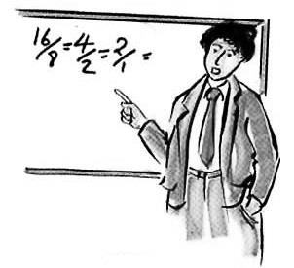**This is a part of a conversation with a teacher about his job. Write the missing questions.**
2. Do you do/work any overtime?
3. Do you get sick pay?
4. How much holiday/how many weeks holiday do you get?
5. What are your working hours?

**A:** _______? **B:** I start at nine and finish at four.

**A:** _______? **B:** Yes, a bit. On certain courses I work until 5.30.

**A:** _______? **B:** 12 weeks. That's one of the good things.

**A:** _______? **B:** Yes, we do, but we have to have a doctor's note.

1. **Project. Imagine you are producing a poster to help local students choose a career. Write a short description of five jobs. Add pictures and titles. Present your leaflet to the group.**

Before you start writing, brainstorm for ideas. Write down everything that comes to mind. This will help you decide what you are going to write about.

**Unit 2. A GOOD TEACHER**

1. **Answer the questions:**
2. What means to be a good teacher?
3. Have you met such teachers? Who are they?
4. **Brainstorm. Work in pairs or small groups and finish the scheme (you can use adjectives or word combinations).**
5. **Read and translate the poem written by Dorothy Law Nolte “Children Learn What They Live”. Do you agree with the author?**

If a child lives with criticism,

He learns to condemn.

If a child lives with hostility,

He learns to fight.

If a child lives with ridicule,

He learns to be shy.

If a child lives with shame,

He learns to feel guilty.

If a child lives with tolerance,

He learns to be patient.

If а child lives with encouragement,

He learns confidence.

If a child lives with praise,

He learns to appreciate.

If a child lives with fairness,

He learns justice.

If a child lives with security,

He learns to have faith,

If a child lives with approval,

He learns to like himself.

If a child lives with acceptance and friendship,

He learns to find love in the world.

1. **A. Look at the list of qualities below. Which, in your opinion, are the most important ones needed to be a good teacher? Listen to the tape and tick (✓) the ones which are mentioned.**

A good teacher should:

1. speak clearly
2. establish a friendly relationship with students
3. have a lot of confidence in front of large groups
4. understand students' individual needs
5. encourage students to be creative
6. keep tight control of a group of students
7. give students a lot of praise and support
8. attend refresher courses regularly
9. spend time preparing lessons thoroughly
10. punish students who don't work hard enough

**B. Which qualities do you think a good teacher should have? Write sentences as in the example*.***

*e.g. I strongly believe that a good teacher should be able to understand students' individual needs.*

1. **Read the texts and translate the words in bold.**

**Some Traits of Character Which a Perfect Teacher Must Obtain**

Being a teacher is a noble and complicated job that **demands** a lot of inner and outer efforts from a person. It stands to reason that not every man who wishes to be a teacher can become it. The point is a real teacher must combine a great number of qualities. These qualities can be divided into some groups: innate qualities, qualities of **mind**, **volitional** powers and qualities **related** to other people.

Let's start with innate qualities. A real teacher cannot be without cheerful character because each lesson should be started with a teacher's smile. Teacher's calm and neat **appearance** helps children tune up to a working mood. If you are inert or a bore, there is no road for you to the teacher profession. Moreover, a teacher must be self-denying and self-critical.

It goes without saying that a good teacher cannot be without broad mind. He must acquire bright and clever head; he must be well-read, intelligent and deep in his subject. Students or pupils cannot accept teachers who are ordinary or shallow.

Teacher's job **requires** a lot of volitional powers. Children are not creatures who are easy to get along with. Children are different with various trends of **character**, facilities and abilities. That is why only firm and strong-willed teachers can succeed in the relationship with pupils. If you feel that you are unable to control your emotions or you are hesitant and weak-willed, just **drop** the idea of being a teacher.

Together with all above-mentioned qualities a real teacher must acquire communicable and **amiable** character. He should be considerate and flexible. A teacher always comes across with so called "a pain in the neck" students, with real **troublemakers**, whose language is awful, who talk back, **resent** any advice, can tell lies and seem to have lost interest in school. While working with such students a teacher must try to analyse the feelings and to find an explanation for this **behavior**. It is difficult indeed: it requires a lot of power and tolerance.

We, future teachers, should remember that pupils need our presence and love. One of the greatest people on the Earth said: A good teacher can govern the state. So the point is being a perfect teacher equals to being a real person.

*(Английский язык для направления «Пед. образование»)*

**Some Advice to the Students Who Have Chosen Teaching as Their Future Job**

Many young people consider teaching as a career. It's not surprising: after your parents your teacher may be the most important person in your life. Have you ever asked yourself why most teachers are so devoted to their work? Maybe because they are doing the most vital job of all. Teaching is not easy and demands a real challenge to your character, **abilities** and talent, as teaching is a constant stream of **decisions**.

Children in your class aren't just boys and girls. Everyone is a unique individual. If you like people, you will love teaching. Remember: an **ignorant** teacher teaches ignorance, a fearful teacher teaches **fear**, and a bored teacher teaches boredom. But a good teacher encourages in his pupils the burning desire to know and love for the truth and beauty.

I would never stop teaching and I'm sure that you, having chosen it for your future career, feel the same way. And if you are ready to accept the responsibility of this wonderful and important work, I wish you all luck in the world.

*A Teacher*

1. **Give the Russian equivalents of the following word combinations and expressions.**

to get through to them; I was not making the grade; don't give it up; the suggested methods; to meet my particular need; I took pains with ... ; I am at a loss; to be familiar with

1. **Find in the texts the English equivalents of the following adjectives and word combinations.**

благородный; дружелюбный; живой; инертный; жертвующий собственными интересами; начитанный; знающий; слабоумный; заурядный; пустой; самокритичный; твердый; настойчивый; волевой; решительный; неуверенный; слабовольный; внимательный; гибкий

1. **Complete the sentences using the following words and word combinations:**

appearance, character traits, behavior, require, troublemaker, behaved, resented, decision, dropped

1. Children grow up with a mixture of _____________ from both sides of their family.
2. He was a little boy, but he ______________ as if he was an adult.
3. I ___________ having to work such long hours.
4. Regulations _____________ that students attend at least 90% of the lectures.
5. She ____________ the idea of being a teacher.
6. She refused to discuss her ____________ to quit the group.
7. The boys were suspended from school for bad _____________.
8. The teacher pegged the young boy as a _______________ from the first day of class.
9. You shouldn’t judge by ____________.
10. **Translate into English using the words from the texts.**
11. Эта проблема требует особого внимания.
12. Мой учитель – очень волевой человек.
13. Эти качества присущи каждому учителю.
14. Учитель должен обладать дружелюбным характером.
15. Они вечно отвергают мои советы!
16. Преподавание требует наличия способностей и таланта.
17. В школе не должны работать необразованные учителя.
18. Некоторые учителя вызывают страх у студентов.
19. **Grammar focus.Fill in: who, whose, which or where.**

My school, 1) ..*which*.. is called King Edward's, has about 2,000 students. My favourite teacher, 2) ……….. is called Mr. Brown, teaches sport. The sports centre, 3) ………… I play basketball and tennis, is the largest in the area. I walk to school every day with my friend Mike, 4) …………. father teaches History.

1. **Grammar focus. Mrs. Potter is the new music teacher at Braxton Academy. Look at the ideas and say what she is going to do as in the example:**
2. offer new courses like Electronic Music and Songwriting

*She is going to offer new course like Electronic Music and Songwriting. ………*

1. invite musicians to play for her students

................................................................................................................................

1. take the students to see the London Symphony Orchestra

*……………………………………………………………………………………………..*

1. organise a concert at the end of the school year

……………………………………………………………………………………………………………………………………………………………………

1. **Write an argumentative (for-against) essay “Being a Teacher” (150-180 words).**
2. **Write ten words and five expressions you are going to memorize.**

|  |  |
| --- | --- |
| **Words** | **Expressions** |
| 1. | 1. |
| 2. |
| 3. | 2. |
| 4. |
| 5. | 3. |
| 6. |
| 7. | 4. |
| 8. |
| 9. | 5. |
| 10. |

**MODULE 4. EDUCATION**

**Unit. 1 THE WORLD OF LEARNING**

*When I hear,****I forget.*** *When I see,****I remember****.  
When I do,****I understand****.*

Chinese proverb

1. **Answer the questions.**
2. What is **“education”?**
3. Where can we get education?
4. If you had a chance, would you go to study abroad?
5. Do you agree that “Learning is a Treasure that will follow us everywhere”?
6. **Brainstorm. Work in pairs or small groups and finish the scheme (you should write 5 nouns, 5 verbs and 2 adjectives).**
7. **a. Which of the following aims of education are most important? Rank them in order of importance, then compare with your partner.**

* to develop understanding of other people / cultures
* to learn social skills
* to prepare for life in the workplace
* to become aware of how the past has affected the present
* to develop critical thinking

**b. Which of the following school subjects/activities help with achieving the above aims?**

• sociology • history • mathematics • geography

• reading and writing • computer studies

• languages • music / art

e.g. *To me, sociology helps us understand other cultures.*

1. **Match the pictures with the following places:** primary school, university, kindergarten, secondary school.

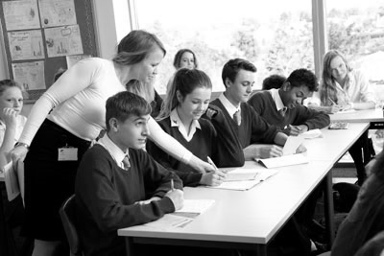

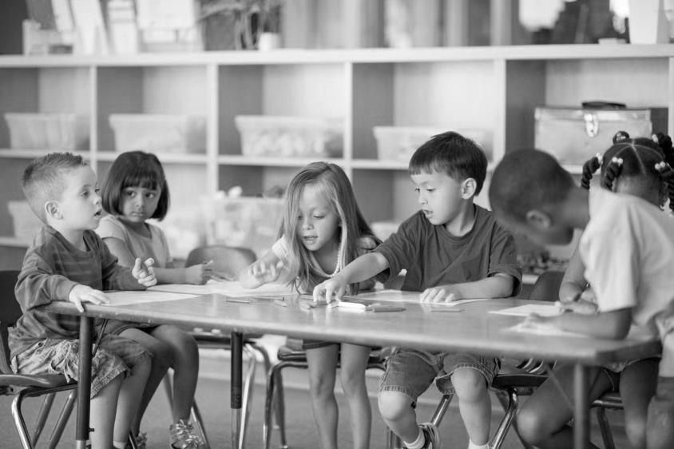

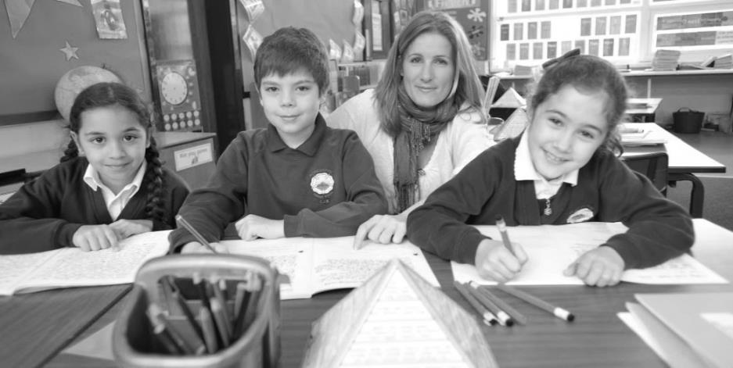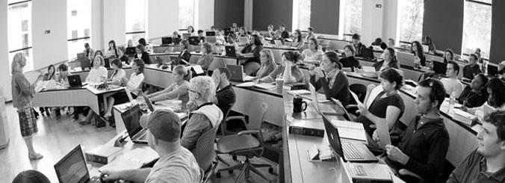



1. **Listen to the dialogue and fill in the gaps.**

* Daddy, when were you born?
* I was born in 1947, in Greenwich.
* What school did you go to?
* First, I went to a 1) _______ school in a small village with only fifty other 2) _________.
* And then?
* Later, my parents and I moved to London where I started 3) _________ school.
* How much can you remember from that time? How many 4) ________ did you study at secondary school?
* A lot of subjects: maths, 5) ________, histo­ry, geography...
* And what was your favourite subject?
* PE, of course.
* How many 6) _________ did you have every day?
* I don't remember exactly, perhaps six or seven...
* Was your school a state school or a 7) ________ school?
* My parents couldn't afford to send me to a public school, so I had to go to a 8) ________ school.
* When did you leave school?
* At the age of 18 I decided to go to 9) _________ and study medicine, as you know.
* Did you like university?
* Well, we had to know every bone in a person's body, but generally it was all right. And what about your future, Mary?
* I want to go to university and study medicine just like you, dad.
* I'm very proud of you but now I think you should finish your 10)_________, don’t you?

*(Easy English)*

1. **Put the words in the box into the correct group.**

college exam homework lecture lesson mark nursery school term

primary school pupil secondary school student teacher university

|  |  |  |  |
| --- | --- | --- | --- |
| **people** | **places** | **study periods** | **work** |
| *…pupil…* | ………… | ………… | ………… |
| ………… | ………… | ………… | ………… |
| ………… | ………… | ………… | ………… |
|  | ………… |  |  |
|  | ………… |  |  |

1. **Match the words from places and study periods in ex. 5 with the definitions.**
2. a place of education for children aged 3 to 5
3. a place of education for children aged 5 to 11
4. a place of education for children aged 11 to 16 or 18
5. a place of education for advanced studies, especially in practical subjects
6. a place of education for studies at the highest level
7. a short period of study at a school
8. a period of study at a college or university when one teacher talks to a large group of students
9. one of the periods of time a year of education is divided into

1. **Complete the sentences with words from people and work in ex.5 which mean the same as the words in brackets.**
2. (children) In this school there are 25 …………… in each class.
3. (person who studies) I’m a …………… at York University.
4. (person whose job is to teach) When I’m older, I’d like to be a …………… .
5. (work my teacher asks me to do at home) I’ve got too much …………… .
6. (letter or number a teacher gives to a piece of work) What …………… did you get? I got a B.
7. (test to see how much you know) I’ve got an …………… tomorrow.
8. **The words below are the names of places one can find in a school. Complete the sentences by choosing the appropriate word.**

gym canteen lab art room classroom staffroom

playing field playground cloakroom library

* 1. Today in the _______________ they had my favourite meal: steak and kidney pie with chips.
  2. When it rains, we have our P.E. lessons inside in the ________________.
  3. 3John nearly blew up the science ______________ last week when he mixed the wrong chemicals together.
  4. The walls of the ______________ are covered in pictures which have been painted by the pupils.
  5. It's always quiet in the _____________ and there are lots of interesting books there.
  6. We have lots of fun in the _______________, playing games or relaxing between lessons.
  7. There are thirty desks and chairs and a big blackboard in our _____________.
  8. You should put your hats, scarves and coats in the ________________.
  9. The ____________ is for teachers only — pupils are not allowed to go in there.
  10. We watched our college team playing rugby on the ____________ yesterday.

1. **Read the text, try to focus on its essential facts, and choose the most suitable heading below for each paragraph.**

1) Different Kinds of Formal Education

2) Formal Education

3) Informal Education

4) What is Education?

**Informal and Formal Education**

Education includes different kinds of learning experiences. In its broadest sense, we consider education to be the ways in which people learn skills,gain knowledge and understanding about the world and about themselves. One useful scheme for discussing education is to divide these ways of learning into two types: informal and formal.

Informal education involves people in learning during their daily life. For example, children learn their language simply by hearing and by trying to speak themselves. In the same informal manner, they learn to dress themselves, to eat with good manners, to ride a bicycle, or to make a telephone call. Education is also informal when people try to get information or to learn skills on their own initiative without a teacher. To do so, they may visit a book shop, library or museum. They may watch a television show, look at a videotape, or listen to a radio programmed. They do not have to pass tests or exams.

We consider formal education to be the instruction given at different kinds of schools, colleges, universities. In most countries, people enter a system of formal education during their early childhood. In this type of education, the people, who are in charge of education, decide what to teach. Then learners study those things with the teachers at the head. Teachers expect learners to come to school regularly and on time, to work at about the same speed as their classmates, and to pass tests and exams. Learners have to pass the exams to show how well they have progressed in their learning. At the end of their learning, learners may earn a diploma, a certificate, or a degree as a mark of their success over the years.

The school system of all modern nations provides both general and vocational education. Most countries also offer special education programs for gifted or for physically or mentally handicapped children. Adult education programs are provided for people who wish to take up their education after leaving school. Most countries spend a large amount of time and money for formal education of their citizens.

*(Английский язык для ВУЗов)*

1. **Read and give a summary of the text.**

**General and Vocational Education**

General education aims at producing intelligent, responsible, well-informed citizens. It is designed to transmit a common cultural heritage rather than to develop trained specialists.

Almost all elementary education is general education. In every country primary school pupils are taught skills they will use throughout their life, such as reading, writing, and arithmetic. They also receive instruction in different subjects, including geography, history, etc. In most countries almost all young people continue their general education in secondary schools.

The aim of vocational education is primarily to prepare the students for a job. Some secondary schools specialize in vocational programs. Technical schools are vocational secondary schools, where students are taught more technical subjects, such as carpentry, metalwork, and electronics. Technical school students are required to take some general education courses and vocational training. Universities and separate professional schools prepare students for careers in such fields as agriculture, architecture, business, engineering, law, medicine, music, teaching, etc.

*(Английский язык для СПО)*

1. **Find in the texts English equivalents for these words and word combinations.**

В широком смысле, обучаются навыкам, получают знания, полезная схема, пути (способы) обучения, официальный, неофициальный, повседневная жизнь, слушая, стараясь, по их собственной инициативе, сдавать экзамены, в большинстве стран, раннее детство, кто отвечает (в ответственности), во главе, вовремя, с приблизительно одинаковой скоростью, одноклассники, должны сдавать экзамены, степень, оценка их успеха, одаренные дети, дети с физическими или умственными недостатками, обучение для взрослых, продолжить после окончания школы, большое количество денег, граждане, общее образование, профессиональное образование, ставит целью, умный, ответственный, хорошо информированный, передавать общее культурное наследство, подготовленные специалисты, начальное образование, на протяжении всей жизни, средние школы, профессиональные программы, профессиональная подготовка.

1. **Find in the texts the words which have the similar meanings as the following words**

to contain, to believe, the means, to study, to get, a kind, to talk, data, various, to be responsible for, a diploma, to want, to continue

1. **Find in the text the words which have the opposite meanings to the following words**

informal, narrow, bad, different, the beginning, old, to give up, small, before

1. **Match the idioms with their definitions.**

|  |  |
| --- | --- |
| **Idioms** | **Definitions** |
| **1** learn by heart | **a** there's always sth you haven't experienced before |
| **2** learn one's lesson | **b** learn sth after making a mistake |
| **3** learn the hard way | **c** memorise sth |
| **4** you are never too old to learn | **d** learn sth (unpleasant) by experiencing it |
| **5** read sb like a book | **e** read with great concentration |
| **6** have one's nose in a book | **f** understand sb's thoughts, ideas clearly |

1. **Make up a short dialogue using one or two idioms above.**
2. **Grammar focus Read the jokes below. See how the verbs *learn* and *study* are used in the context. Retell the jokes in indirect speech.**
3. A young teacher just beginning his career asks advice of an older member of the faculty: “What have you learned in your years of experience?

“I've learned one thing. Often you will find while you are giving a lesson in class that there is one young upstart who always disagrees with you. Tell me, would you stop him and try to make him shut up right then and there?”

“I suppose I would.”

“Well, don't. He's probably the only one who is listening to you.”

1. A high-school girl seated next to a famous astronomer at a dinner party struck up a conversation asking, “What do you do in life?”

He replied, “I study astronomy.”

“Dear me,” said the young miss, “I finished astronomy last year.”

1. **Translate the sentences using the words learn and study in their different meanings:**

1. В молодости он изучал химию в университете. 2. Дети легко учат иностранные языки. 3. Я очень огорчился, когда узнал, что не сдал экзамен. 4. Весь вечер он занимался в своей комнате. 5. Изучите эту информацию очень внимательно: она поможет вам сделать правильный выбор. 6 Моя сестра учится, чтобы стать юристом. 7. К сожалению, он так и не научился читать и писать. 8. Вам еще предстоит научиться, как справляться с трудными проблемами на уроках.

1. **Match the types of schools (1-6) to the descriptions (A-F). Which are the most common/uncommon in our country? What type of school did you go to?**
2. boarding school
3. single sex school
4. co-educational school
5. specialist school
6. state school
7. private school
8. A school for boys and girls.
9. A school you usually have to pay to go to.
10. A school students go to for a particular reason (e.g. to become actors).
11. A school for only boys or only girls.
12. A school owned by the government.
13. A school which students live in during school term.
14. **Read the following statements. Which ones were true for your school? Which ones are true for your college?**

* Students wear a uniform.
* There are lots of rules.
* Facilities and equipment are good (e.g. libraries, science labs, sports equipment).
* The teachers are strict.
* Students are motivated.
* There is a selection of unusual subjects to choose from.
* Students sit a lot of exams.
* Most students take part in extra-curricular activities (e.g. drama, sports).
* Students get a lot of homework.
* Most students live nearby.

**What would you like to change? Why? Discuss.**

e.g.: *I liked* wearing *a school uniform./ I don't like wearing a uniform. I'd rather* *wear something* *more fashionable…*

**Unit 2. AROUND THE WORLD**

*Education is a movement*

*from darkness to light.*

*(Allan Bloom)*

1. **Read the text and label the paragraphs (A-E) with the headings below. One heading does not match. What is the main idea of each paragraph?**

1) To and From School

2) School Rules

3) Education or No Education

4) Schools of Every Shape and Size

5) Studying Hours

6) Home Schooling

**Schools around the world**

A □

There are many types of schools in the world. Some are expensive, private boarding schools. Like Rugby School in England where the game of rugby was invented! There are also some specialist schools, like drama schools, dance schools or the 40 acrobatic schools in Wuqiao, China. It might sound like fun, but, as 13-year-old Zhang Li explains, “Our training starts at 5:30 a.m. It's very hard, but these skills will help me earn a living when I leave.” There are also a wide range of school subjects at different schools. At Holden High School in the USA subjects include comic book art, photography, song writing and yoga.

B □

At a school in the Annapurna mountains in Nepal, classes don't start until 10 a.m. because a lot of students have to walk for about an hour to get there. In Japan, it isn't unusual for students to spend two hours or more getting to school on public transport. “It's not so bad.” says 15-year-old Keiko from Tokyo. “I sometimes sleep or study on the train, and it's a great way to catch up with my friends”.

C □

The average school day in the UK and the US is 6.5 hours for high school students. Students in Korea and Greece, however, are not so lucky! After school they attend extra classes in private schools. “On a typical day.” says Jie Kim from Seoul, South Korea. “I don't get home until midnight, but if I don't study hard, I won't get into a good university."

D □

All schools have rules, but sometimes they are really strict. At Eton College, a very famous boys’ boarding school in England, the students have a smart but very old-fashioned uniform with a long jacket, trousers and shirt. In Japan, everyone has to participate in ‘o soji’, or the cleaning of the school, before they go home, whereas at Summerhill School in England, it's the students who make the rues!

E □

So, is your school better or worse than schools in other parts of the world? No matter what your answer is, we shouldn't forget that 300 million children in the world don't have any schools to go to. So even if you'd like to change some things about your school, you really are one of the lucky ones!

*(Spotlight 10)*

1. **Write a short article about the school you studied at (60-80 words).** Write: type of school and classes, how students get there, hours, rules.
2. **Nowadays the necessity of studying abroad has become an emerging trend among the youth. However, every coin has two sides and so does going abroad to study. It has countless advantages as well as disadvantages that should be taken into consideration.**Think for 1 minute and make a list of 3 advantages and 3 disadvantages of being an exchange student.

|  |  |
| --- | --- |
| The advantages of being an exchange student | The disadvantages of being an exchange student |
| 1. | 1. |
| 2. | 2. |
| 3. | 3. |

**Exchange the ideas with your partner. Add to your list the ideas you agree with.**

1. **Look through the new list. Tick the ideas that have not been mentioned yet. Are they advantages or disadvantages of being an exchange student? Explain why you think so.**
2. Making new friends
3. Exploring and understanding new cultures
4. Experiencing culture shock
5. Eliminating fear and prejudice among nations
6. Getting career advantage
7. Having a communication barrier
8. Developing as a person
9. Improving your language skills
10. Having new educational experience
11. Feeling homesick
12. Gaining self-confidence
13. Speaking a foreign language all day long
14. Living independently
15. Creating a long-lasting relationship with a host family
16. **Read the extract from the Convention on the Rights of the Child and translate it into Russian.**

***Article 28***

**1.** States Parties recognize the right of the child to education and with a view to achieving this right progressively and on the basis of equal opportunity, they shall, in particular:

**(a)** Make primary education compulsory and available free to all;

**(b)** Encourage the development of different forms of secondary education, including general and vocational education, make them available and accessible to every child and take appropriate measures such as the introduction of free education and offering financial assistance in case of need;

**(c)** Make higher education accessible to all on the basis of capacity by every appropriate means;

**(d)** Make educational and vocational information and guidance available and accessible to all children;

**(e)** Take measures to encourage regular attendance at schools and the reduction of drop-out rates.

**2.** States Parties shall take all appropriate measures to ensure that school discipline is administered in a manner consistent with the child’s human dignity and in conformity with the present Convention.

**3.** States Parties shall promote and encourage international cooperation in matters relating to education, in particular with a view to contributing to the elimination of ignorance and illiteracy throughout the world and facilitating access to scientific and technical knowledge and modern teaching methods. In this regard, particular account shall be taken of the needs of developing countries.

1. **Read the letter and answer the questions.**
2. What is the letter about?
3. Are the children that Mrs. Myles met receiving a good education? Why/why not?
4. Do you know places in our country where children have also difficulties with receiving complete secondary education?
5. Could you go to teach in a very distant district if you knew that there was no teacher there?

Sao Sebastia о de Jacara, Brazil

20th April

To all the pupils and teachers at Mill House Secondary School,

Greetings from Brazil! I've been here for just а wееk, but already I have so much to share with you about the children and teachers I've met here!

Sadly, conditions at the village school here are much worse than I expected. For example, there are pupils here from 7 to 11 years old, and there is only one teacher, Mrs. Da Silva, and she teaches them all at the same time. For this reason, they only go to school for four hours a day. Mrs. Da Silva tries really hard and she is so busy that it's impossible for her to give everyone the help they need. She is also not very well- paid and gets no support.

What is more, if the children want to continue school after Year 4, then they have to go and live in Porto De Moz, the town where the nearest large school is. Unfortunately, though, this means that they have to stay with another family and get a job to pay for their rent and food because it is quite far away. An 11-year-old student called Eliane told me that's what his brothers and sister do and he only sees them twice a year when they come home for the holidays. He wants to finish school, but he doesn't want to leave his family. He wouldn't have to make this tough decision if his school had more teachers.

Did you know Brazil is not the only country that needs more teachers? Over 15 million teachers are needed around the world so that children can go to school and get an education. I think we should do something to help. We could write a letter to the Prime Minister or we could organise some sponsored events to raise money. Why don't you all think of some ideas and when I come back we can put them into action?

See you all in a couple of weeks!

Regards,

Ann Myles

*(Spotlight 10)*

1. **A. Look at the following statements. Do you agree with them? Why? Discuss.**

All children in the world should be able to go to school.

Classes should not have more than 30 children.

Teachers do a very difficult job and should be paid well.

All children should expect to be helped when they have difficulties in school.

All children should have the right to a free education.

**B. Use your ideas and write an essay “All children should receive a good and free education”**

1. **Game.** **Unscramble each of the clue words. Copy the letters in the numbered cells to the other sells with the same number.**

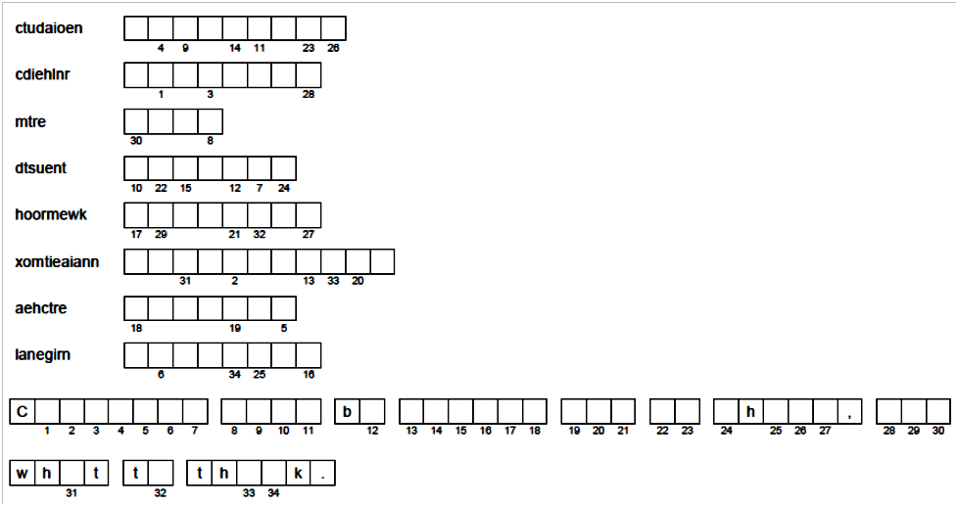

1. **Choose a topic and write an essay (150-180 words).**

1. Some people believe the aim of university education is to help graduates get better jobs. Others believe that there are much wider benefits of university education for both individuals and society. Discuss both views and give your opinion.

2. Education is not a luxury, but a basic human right and as such should be free for everyone irrespective of personal wealth. Do you agree or disagree with this statement?

3. Some people think that children's free time must include educational activities, otherwise they will waste their time. What is your opinion?

4. Formal examinations are the only effective way to assess a student's performance. Continual assessment such as course work and projects is not a satisfactory way to do this. To what extent do you agree or disagree with this statement?

5. The subjects that children are taught in schools are chosen by central authorities. Some people say that teachers, not politicians, should be responsible for this task. To what extent you agree or disagree with this opinion?

6. Some experts believe that it is better for children to begin learning a foreign language at primary school rather than secondary school. Do the advantages of learning a foreign language at an early age outweigh the disadvantages?

1. **Write ten words and five expressions you are going to memorize.**

|  |  |
| --- | --- |
| **Words** | **Expressions** |
| 1. | 1. |
| 2. |
| 3. | 2. |
| 4. |
| 5. | 3. |
| 6. |
| 7. | 4. |
| 8. |
| 9. | 5. |
| 10. |

**Структура эссе на английском языке**

Структура эссе по английскому языку универсальна и состоит из следующих частей:

**Заголовок** — название эссе, отражающее тему повествования.

**Введение** — 2-4 коротких предложения, раскрывающих тему эссе.

**Основная часть** — 2 абзаца, описывающих суть сочинения. В них вам нужно максимально полно и грамотно раскрыть тему, привести доводы и аргументировать их.

**Заключение** — 2-4 предложения, подводящих итог написанному. В этой части вы делаете общий вывод по теме эссе.

Для начала лучше всего сделать наброски того, что вам известно по теме эссе. Чтобы действовать целенаправленно, составьте план:

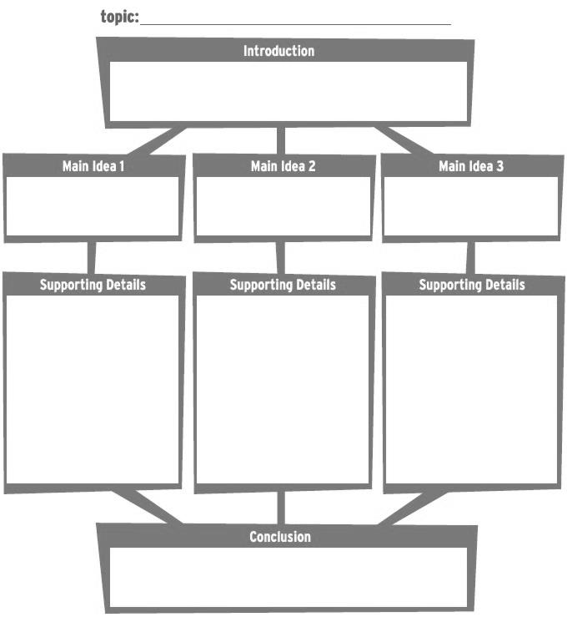

Виды эссе по английскому языку и их особенности

Вид эссе по английскому языку, которое вам нужно написать, зависит от заданной темы и иногда указывается в задании. Согласно книге *Successful Writing* автора *Virginia Evans* — принято выделять три основных вида эссе:

**1. За и против. Argumentative (for and against) essays**

Название говорит само за себя: вы приводите аргументы «за» и «против» какого-то явления. План эссе на английском языке следующий:

*Введение.* В нем вы подводите читателя к теме обсуждения. Начните с общего представления темы (In today’s world… it is important) и предложения, выражающего её двойственный характер (It can be regarded as… but …).

*Основная часть.* Вы приводите аргументы «за» и «против» какого-то действия или явления. Вы можете представить аргументы “за” и “против” в отдельных абзацах. При этом не надо высказывать свою точку зрения, придерживайтесь нейтралитета.

Типичные союзы и союзные обороты: on the one hand… on the other hand; However, Despite this, In spite of this; In fact, As a matter of fact; As a result. Другие выражения: One major advantage is…, There are a number of disadvantages / drawbacks .

*Заключение.* Вы выражаете свое отношение к теме и делаете вывод. (All in all, To sum up, In conclusion, In general; it seems important to add/point out/remind that…)

**2. Эссе-мнение. Expressing opinion essays**

Сочинение “expressing opinion” пишется в формальном (деловом) стиле.

В данном типе сочинения требуется выразить свою точку зрения на заданную тему, а так же привести противоположные вашей точки зрения других людей и объяснить, почему вы с ними не согласны. Ваше мнение должно быть четко сформулировано и подкреплено примерами или доказательствами. План эссе-мнения по английскому:

*Введение.* Вы указываете тему рассуждения. Рекомендуемое окончание первого абзаца: Now I would like to express my point of view on (noun) …

*Основная часть.* *1 абзац.* Привести 2-3 аргумента, подтверждающих вашу точку зрения, подкрепляя их примерами или доказательствами. *2 абзац.* Привести противоположные точки зрения (1-2), и объяснить, почему вы с ними НЕ согласны. Пример: However, some people think that ... I can’t agree with this statement because…

Ваши контраргументы мнению других людей не должны повторять 2ой абзац.

*Заключение.* Необходимо сделать вывод, обратившись к заданной в 1-м параграфе теме, что существуют 2 точки зрения на проблему, а также подтвердить собственную точку зрения. Например: «There are different points of view on this problem. I think that…» или «Taking everything into consideration, there are two different points of view on this problem. I believe that…

Useful vocabulary

**1 абзац. Вводные фразы**

This essay deals with... (Это эссе посвящено...)

A lot of people think that…

It is often suggested /believed that…

Many people think … but others do not agree. (Многие люди думают, (что) ... , но другие не согласны.)

**2 абзац. Фразы, перечисляющие точки зрения:**

Firstly, /First of all….

In the first place

To start with, / To begin with,

Secondly, Thirdly, Finally,

Last but not least,

**Фразы, добавляющие новые аргументы:**

Furthermore, /Moreover, /What is more,

As well as…. /In addition to this/that…

Besides, /…….also….

Not only…., but…… as well.

**3 абзац.**

Some people believe that… however they fail to understand that…/ they forget that…

Some people argue that …. I can not agree with it as …

I disagree with this point of view (statement, opinion) because …

Contrary to what most people believe, I think that…

As opposed to the above ideas…I believe that…

**4 абзац. Заключительные фразы:**

In conclusion,

On the whole,

To conclude,

To sum up,

All in all,

All things considered

Finally,

Lastly,

Taking everything into account,

Taking everything into consideration

**Выражение личного мнения:**

In my opinion …

From my point of view, …

To my mind, …

Personally I believe that…

It seems to me that…

**3. Предложение решения проблемы. Suggesting solutions to problem essays**

В этом виде письменной работы вам предложат рассмотреть какую-либо глобальную проблему или проблемы. Ваша задача — предложить пути решения. План этого вида эссе следующий:

*Введение.* Вы указываете проблему и ее причины или последствия.

*Основная часть.* Вы предлагаете способы решения проблем и возможные последствия таких действий. Четко аргументируйте, зачем следует принимать определенные меры и что это за собой повлечет.

*Заключение.* Подводите итоги своих рассуждений.

**Структура написания сочинения на тему «Мой первый уpок» («Му First Lesson»)**

**I. Вступление (50 слов).**

Words you may need

teaching practice - педагогическая практика

to consult with the class teacher - советоваться c учителем

to meet the pupils - встретиться c учениками

classroom observation - пассивная практика

curious - любопытный

interested in - ивтересующийся чем-либо, заинтересованньй в чем-либо

enthusiastic about - yвлеченньй чем-либо, полный энтузиазма

anxious about - беспокоящийся, волнующийся о чем-либо

to worry about - беспокоиться, переживать o чем-либо

confident about - уверенный в чем-либо

embarrassed - растерянный

- Кратко расскажите o своей практике (как происходило ваше знакомство c классом (группой) / учащимися? Как реагировали на вас учащиеся? Какие отношения сформировались y вас c учителями и классным руководителем? )

- Опишите свои ощущения, переживания, чувства (переполнял ли вас энтузиазм и желание не только учить детей, но и проводить c ними больше времени, отдавая себя полностью этому занятию? Испытывали ли вы волнение или вы были уверены в своих умениях и навыках преподавания?)

**II. Описание уpока (100 слов).**

Words you may need

Lesson preparation - подготовка к уроку

Classroom performance - проведение урока

It was difficult - это было трудно

I spent much time getting prepared for ... - я долго готовился/готовилась к

The pupils were cheeky/ disobedient/ obedient/ clever - ученики были дерзкими/непослушными/послушными/умными

I got on well with the children / the head teacher (supervisor) - я хорошо поладил (-a) c детьми, учителем

It was pleasant and easy to work with the pupils - работать c учениками было приятно и легко

The teacher gave me lots of pieces of advice, such as ... - учитель дал мне много советов, таких как

The teacher's advice was very valuable/ relevant/ competent - совет учителя был ценным, уместным, компетентным

- Урок по какому предмету вы провели и в каком классе?

- Возникали ли y вас трудности в процессе подготовки к уроку?

- Старались ли вы сделать ваш урок необычным, творческим или более стандартным? - Расскажите o трудных моментах в работе c детьми (поддержание дисциплины, следование всем методическим принципам, акцент на личностном общении c детьми, обсуждение тем, близких по духу данной возрастной группе, соблюдение временных рамок)

- Расскажите o наиболее увлекательных аспектах в работе c учащимися.

- Какую роль играл учитель (классный руководитель): активную (принимал участие в процессе урока) или пассивную (наблюдал и не вмешивался в ход урока)?

- Опишите эмоции, которые вы переживали в тот момент (волнение, страх, радость, душевный и эмоциональный подъем)

**III. Заключение (50 слов).**

- Какие напутствия дали вам учителя? Что важного и необходимого вы вынесли для себя после проведения урока?

**Общий объем эссе - не менее 150 слов.**

**Памятка-инструкция**

**Как определить значение слова в тексте**

**Цель:** научиться правильно определять значение незнакомых слов. Многие слова в английском языке имеют не одно, а несколько значений. Встретившись с таким словом, важно правильно определить его значение в тексте. Для этого необходимо:

1)прочесть предложение и определить к какой части речи относится данное слово,

2)найти нужную словарную статью;

3)найти в ней нужную часть речи;

4)выбрать то значение, которое подходит по смыслу.

**Памятка-совет**

**Как быстро найти нужную информацию**

**Цель:** развивать навык поискового чтения.

1) Убедитесь, что вы чётко представляете какую информацию вам надо найти в тексте.

2) Не останавливайтесь при чтении на каждом незнакомом слове, незначительной для вас информации.

3) Обращайте особое внимание на опознавательные знаки, слова которые могут подсказать, где в тексте находится необходимая вам информация (заглавные буквы - для ответа на вопросы кто? где?, цифры – сколько? когда?)

При аудировании с целью извлечения конкретной информации следуй тем же советам памятки.

**Памятка – совет - инструкция**

**Как научиться понимать всё, о чём читаешь**

**Цель:** развивать навык изучающего чтения.

1) Прежде всего, прочитайте весь текст и попытайтесь понять общий смысл. Это поможет затем глубже вникнуть в детали при повторном чтении.

2) Если при повторном чтении встречаются незнакомые слова, не спеши те обращаться к словарю. Постарайтесь понять значение незнакомого слова по общему смыслу предложения.

3) Если не получается, попробуйте сопоставить его со словами русского языка.

4) Если оно не напоминает вам никаких слов, посмотрите, из каких элементов состоит слово.

5) Если все перечисленные способы не помогли вам, остаётся последний – обращение к словарю. Главное, не оставлять ключевые слова без точного перевода.

**Список рекомендуемой литературы**

1. Англо-русский учебно-педагогический словарь - The Learner's English-Russian Dictionary of Education. [Текст] / Сост. Н.В.Фёдорова, В.П.Лапчинская. – М.: ИЗДАТ-ШКОЛА, 1998. – 160 с. Большой русско-английский словарь: ок.50 000 слов. С прил. крат. сведений по англ. грамматике и орфоэпии, сост. А.И. Смирницким. [Текст] / Сост. О.С. Ахманова, З.С. Выгодская, Т.П. Горбунова; Под. общ. рук. А.И. Смирницкого. – М.: Русский язык, 2003. – 768 с.
2. Артемова А.Ф. English for Teachers / Английский язык для педагогов. [Текст] / А. Ф. Артемова, О. А. Леонович. – Флинта, 2014. – с.264
3. Голубев А.П. Английский язык: учебное пособие для студентов средних профессиональных учебных заведений. [Текст] / А.П. Голубев, Н.В. Балюк, И.Б. Смирнова. – 7-е изд., стер. – М.: Издательский цент «Академия», 2009. – 336 с.
4. Онлайн словарь издательства Макмиллан [Электронный ресурс] // URL: <http://www.macmillandictionary.com> (дата обращения 09.03.2016).

**Список использованных источников**

1. Evans V. Enterprise 4 (Intermediate). [Текст] / Virginia Evans, Jenny Dooley. – Express Publishing, 1998. - 198 p.
2. Evans V. New Round-Up 4. [Текст] / Virginia Evans, Jenny Dooley. – 4th publ. – L.: Longman, 2010. – 208 p.
3. Evans V. Upstream. Elementary. [Текст] / Virginia Evans, Jenny Dooley. – Express Publishing, 2005. – 134 p.
4. Evans V. Upstream. Pre-Intermediate. [Текст] / Virginia Evans, Jenny Dooley. – Express Publishing, 2004. - 152 p.
5. McCarthy, M. English Vocabulary in Use. Elementary [Текст] / Michael McCarthy, Felicity O'Dell. – Cambridge: University Press, 2008. - 168 p.
6. Pey G. Vocabulary in Practice. 2. Elementary [Текст] / Glennis Pey. – Cambridge: University Press, 2002. – 63 p.
7. Redman, S. English Vocabulary in Use. Pre-intermediate and intermediate. [Текст] / Stuart Redman. – Cambridge: University Press, 2009. - 263 p.
8. Аракин В.Д. Практический курс английского языка. 2 курс. [Текст] / Л.И. Селянина, Л.Г. Любимова, и др.; под ред. В.Д. Аракина; 5-е изд., перераб. и доп. – М.: Владос, 1998. – 520 с.
9. Афанасьева О.В. Английский язык. 10 класс: учеб. для общеобразоват. учреждений. [Текст] / О.В. Афанасьева, Д. Дули, И.В. Михеева и др. – 5-е изд. – М.: Express Publishing, Просвещение, 2012. – 248 с.
10. Биболетова М.З. Английский язык. Enjoy English. 11 класс [Текст] / З.М. Биболетова, Е.Е. Бабушис, Н.Д. Снежко. – 2-е изд., испр. - Обнинск: Титул, 2011. – 200 с.
11. Восковская А.С. Английский язык для средних специальных учебных заведений. [Текст] / А.С. Восковская, Т.А. Карпова. – Изд. 2-е, перераб. и доп. – Ростов н/Д: Феникс, 2005. – 384 с.
12. Голубев А.П. Английский язык: учебное пособие для студентов средних профессиональных учебных заведений. [Текст] / А.П. Голубев, Н.В. Балюк, И.Б. Смирнова. – 7-е изд., стер. – М.: Издательский цент «Академия», 2009. – 336 с.
13. Степанова С.Н. Английский язык для направления «Педагогическое образование»: учебник для студ. учреждений высш. проф. образования / С.Н. Степанова, С.И. Хафизова, Т.А. Гревцева; под ред. С.Н. Степановой. – 5-е изд., стер – М.: Идательский центр «Академия», 2014. – 224 с.
14. Онлайн словарь издательства Макмиллан [Электронный ресурс] // URL: <http://www.macmillandictionary.com> (дата обращения 09.03.2016).

Учебное пособие

*Драгина Ксения Юрьевна*

МАТЕРИАЛ ПО ОРГАНИЗАЦИИ ПРАКТИЧЕСКИХ ЗАНЯТИЙ

**по дисциплине «Иностранный язык (английский)»**

**ДЛЯ СПЕЦИАЛЬНОСТИ**

**44.02.02 Преподавание в начальных классах,**

*Подписано в печать 28.08.2021.*

*Бумага листовая для офисной техники.*

*Усл.-печ.л. 3,71. Тираж 50 экз.*

изд. ГБПОУ «ССПК»

**г.о.Самара,2021**